# **NaanMudhalvan Project Submission Report**

[**SERVICENOW**]

Title:**Educational Organization using Servicenow**

College: Dharmamurthi rao bahadur calavala cunnan chetty’s **Hindu College**

College code:**Unm110**

Team members:

**1.Santhosh.V**

**2.Vignesh.J**

**3.Viswanathan.I**

**4.Gokul.M**

**1. Introduction**

The project focuses on building an **Educational Organization Management System** using ServiceNow. The aim is to automate and simplify operations related to admissions, student progress tracking, and overall institutional processes.

**2. Project Tasks and Implementation**

1. **Setting up ServiceNow Instance**
   * A personal developer instance of ServiceNow was created to carry out the project tasks.
   * The instance provided a cloud-based environment for customization and workflow development.
2. **Creating an Update Set**
   * An Update Set was created to capture all customizations and configurations made during the project.
   * This ensures portability and version control of the developed application.

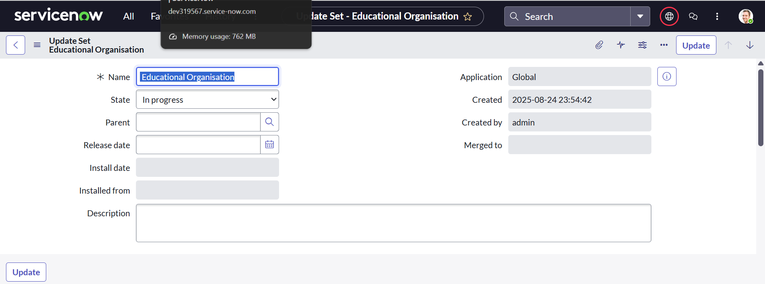

1. **Creating Custom Tables**
   * **Salesforce Table:** Designed to store data related to external integrations and sales activities.
   * **Admission Table:** Created to manage student admission records including application details and approvals.
   * **Student Progress Table:** Developed to track academic performance, subjects, results, and overall progress of students.

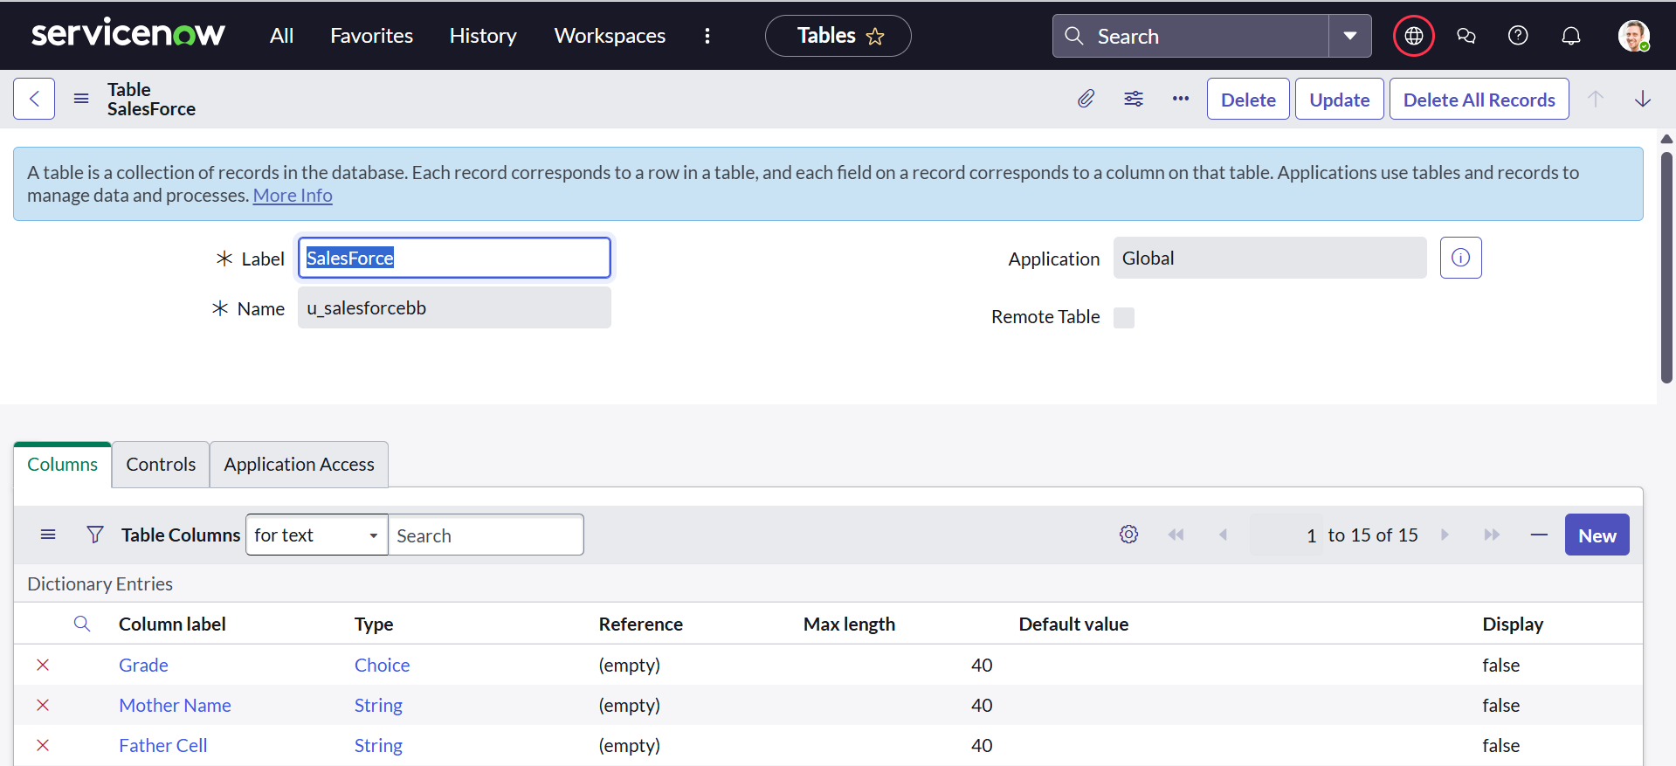 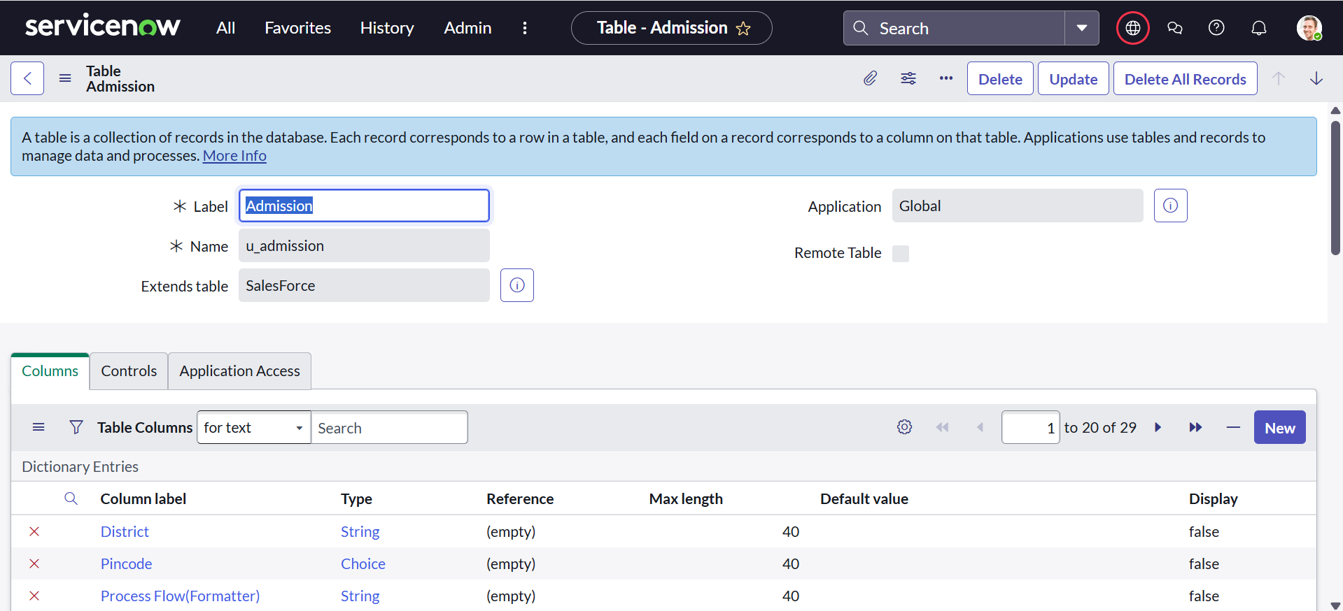

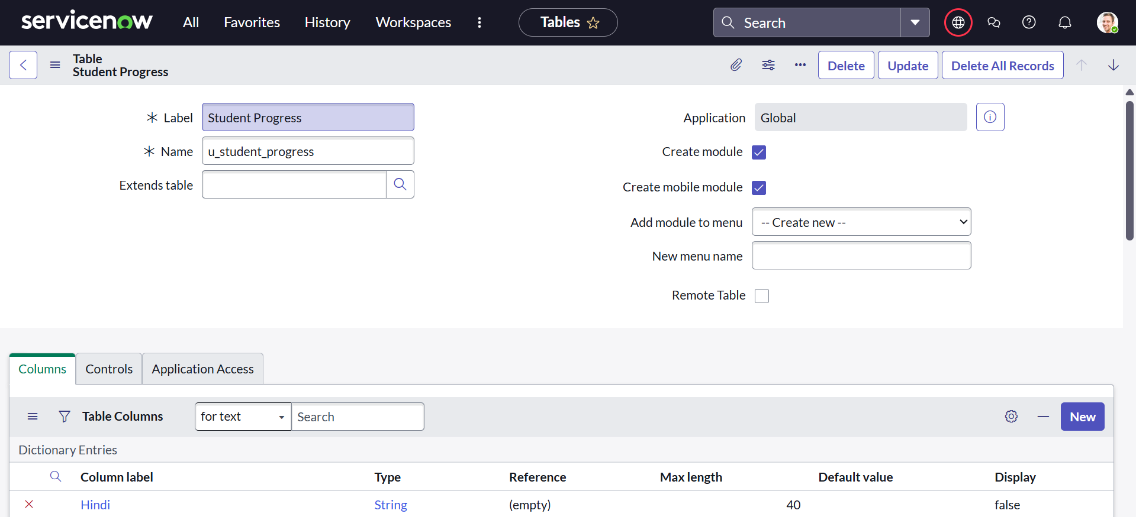

1. **Form Layout for Student Progress Table**
   * Customized the form layout to display key fields such as subjects, marks, results, and percentages.
   * Improved usability by grouping related fields for better clarity.

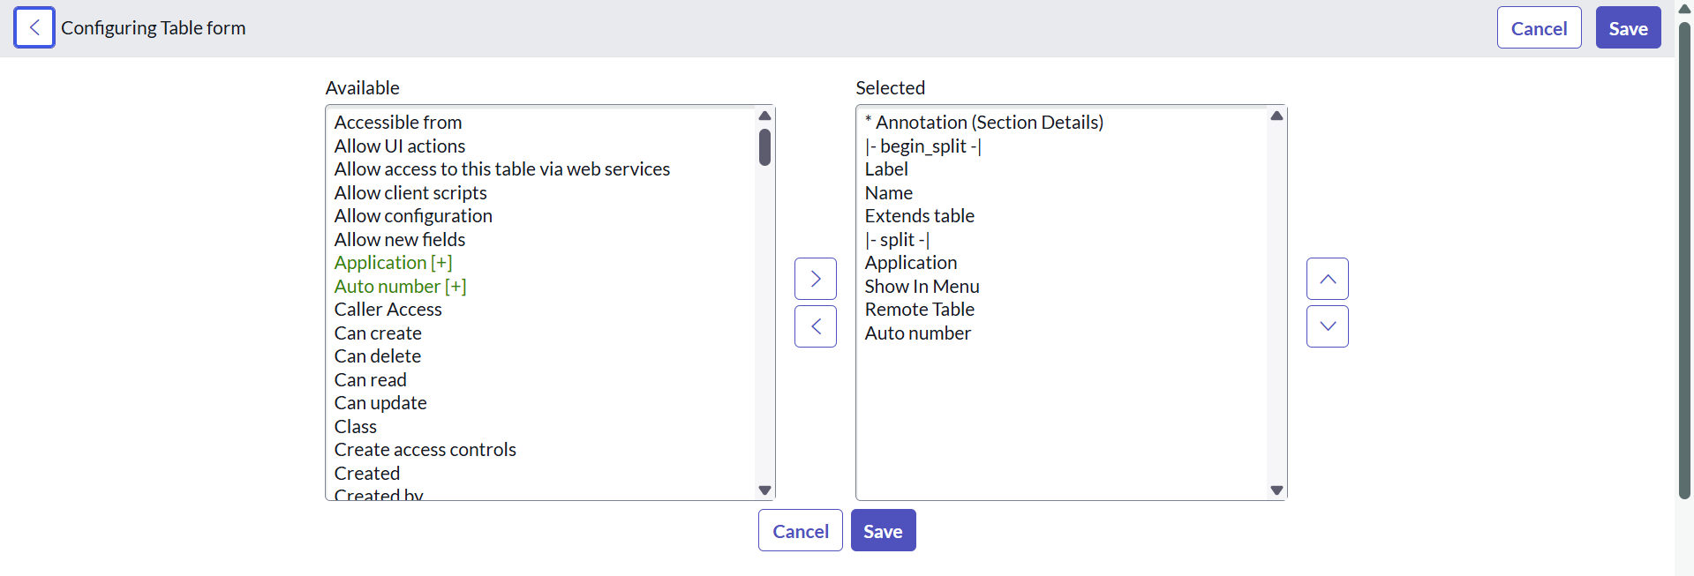

1. **Form Design for All Three Tables**
   * Designed forms for Salesforce, Admission, and Student Progress tables.
   * Implemented logical field arrangements for efficient data entry and viewing.

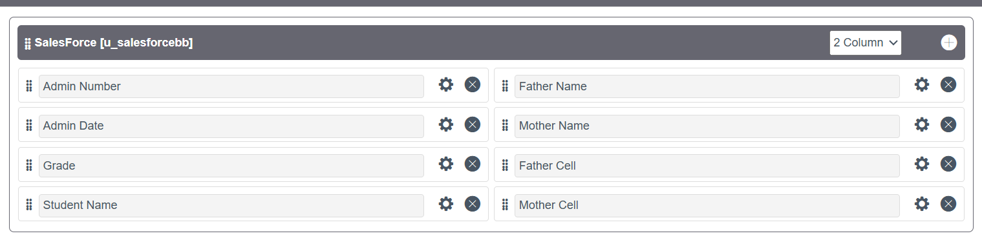

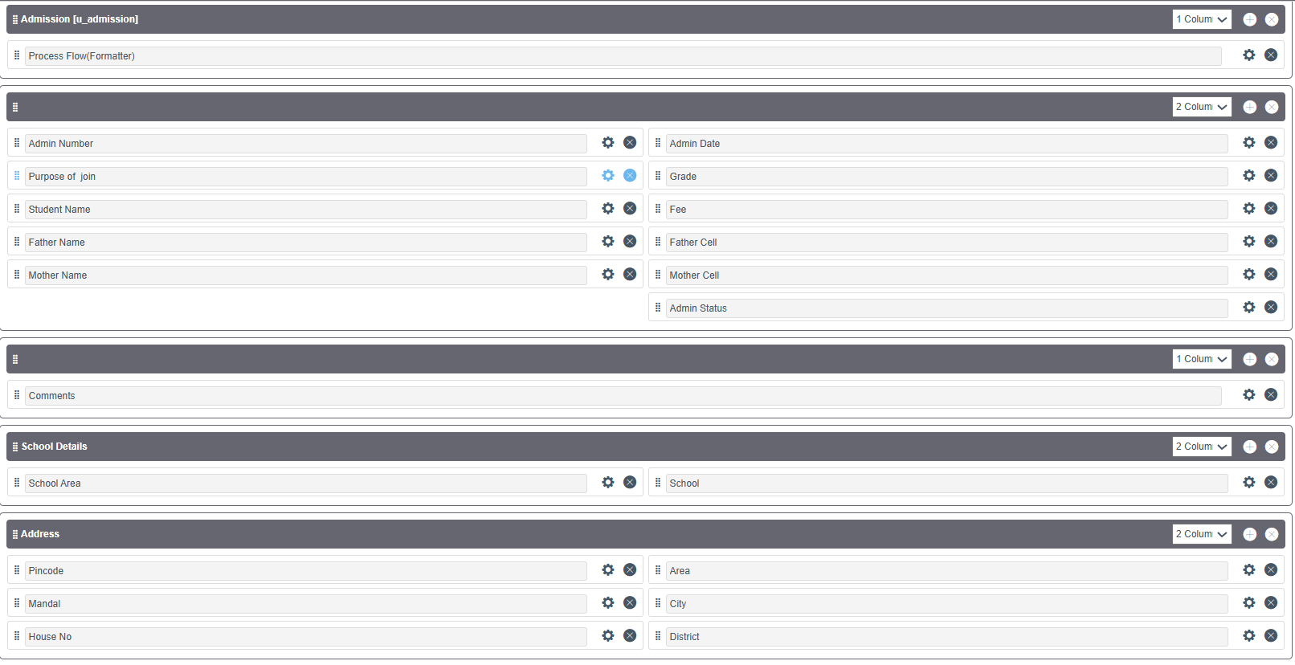 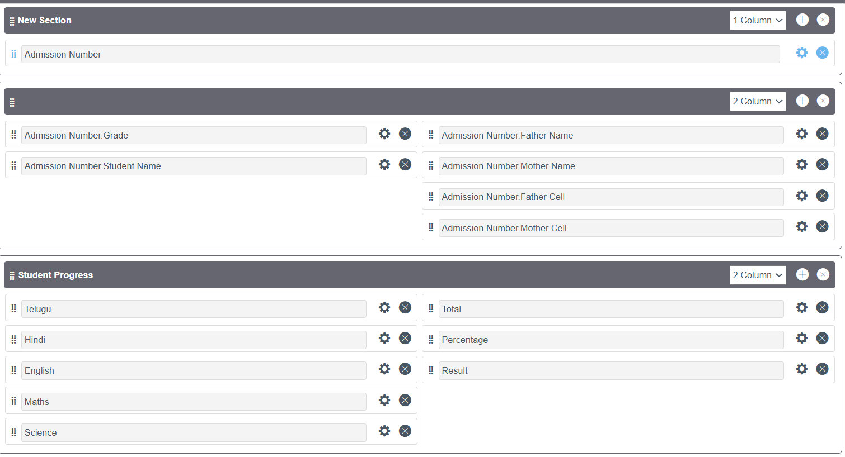

1. **Number Maintenance for Admission Table**
   * Configured **Number Maintenance** to automatically generate unique admission numbers for each student record.
   * Ensured consistency and uniqueness of student admission identifiers.

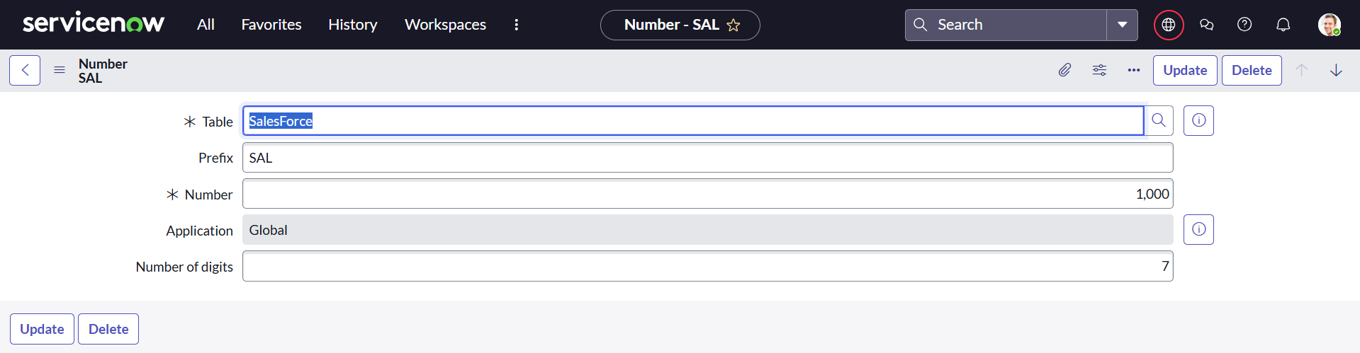

1. **Process Flow for Admission Table**
   * Designed a process flow to represent the stages of admission such as Application Submission → Verification → Approval/Rejection.
   * Used Flow Designer to automate approvals and status updates.

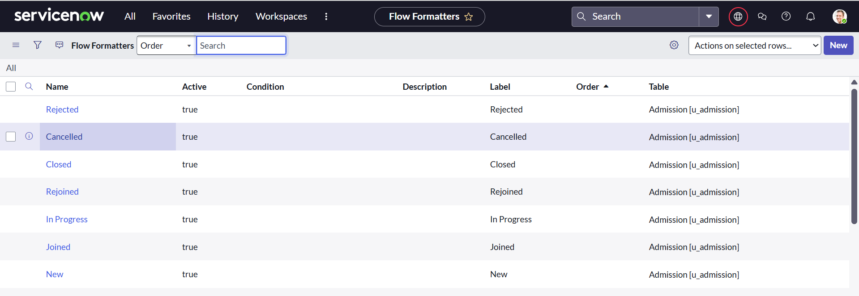

1. **Client Scripts Development**
   * **Auto Populate Script (Admission Table):** Automatically filled certain fields based on user input (e.g., auto-filling name or course).
   * **Pincode Update Script (Admission Table):** Updated city and state automatically based on the entered pincode.
   * **Disable Fields Script (Student Progress Table):** Certain fields were disabled to prevent unauthorized modification.
   * **Total Update Script (Student Progress Table):** Automatically calculated the total marks obtained by a student.
   * **Result Script (Student Progress Table):** Generated pass/fail results based on total and subject marks.
   * **Percentage Script (Student Progress Table):** Calculated percentage scores dynamically when marks were updated.

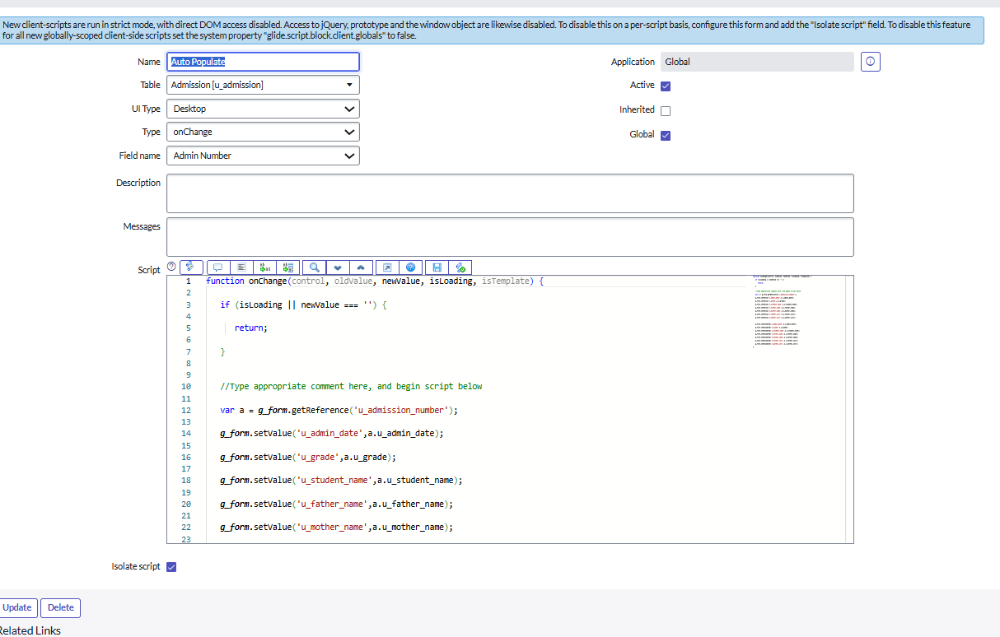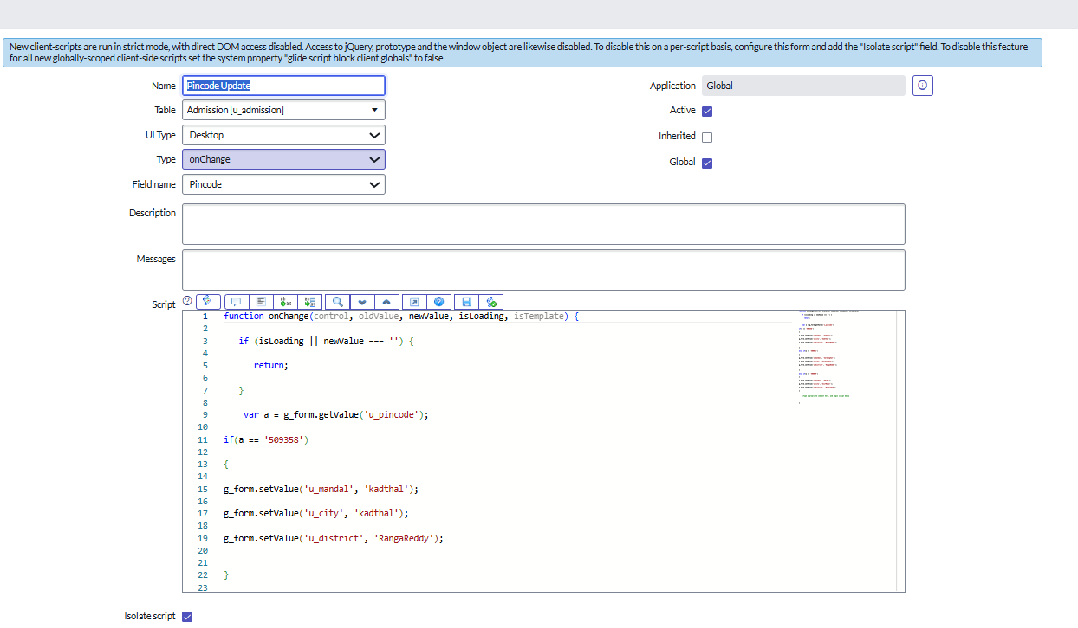

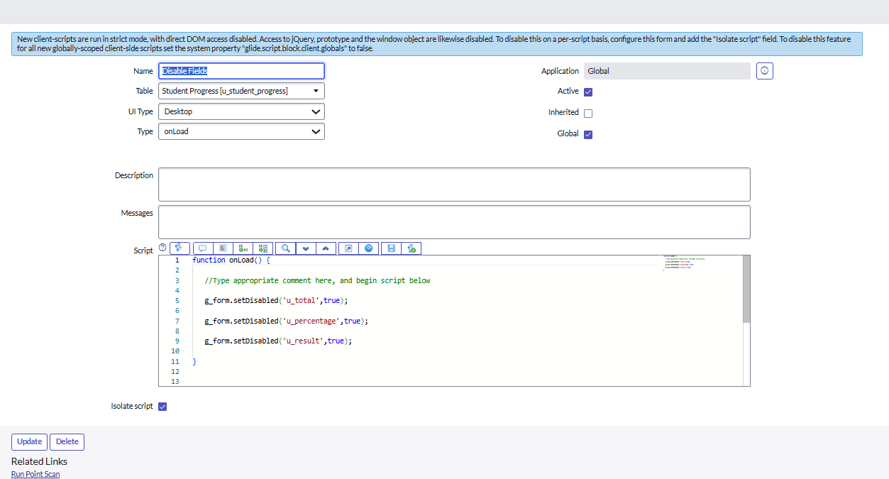

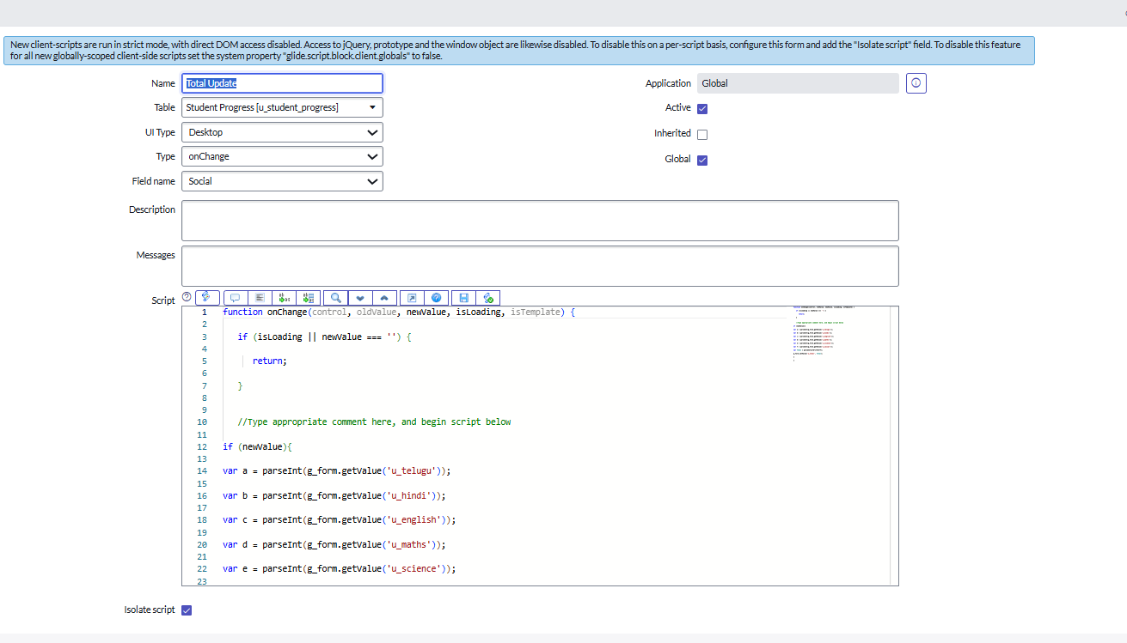

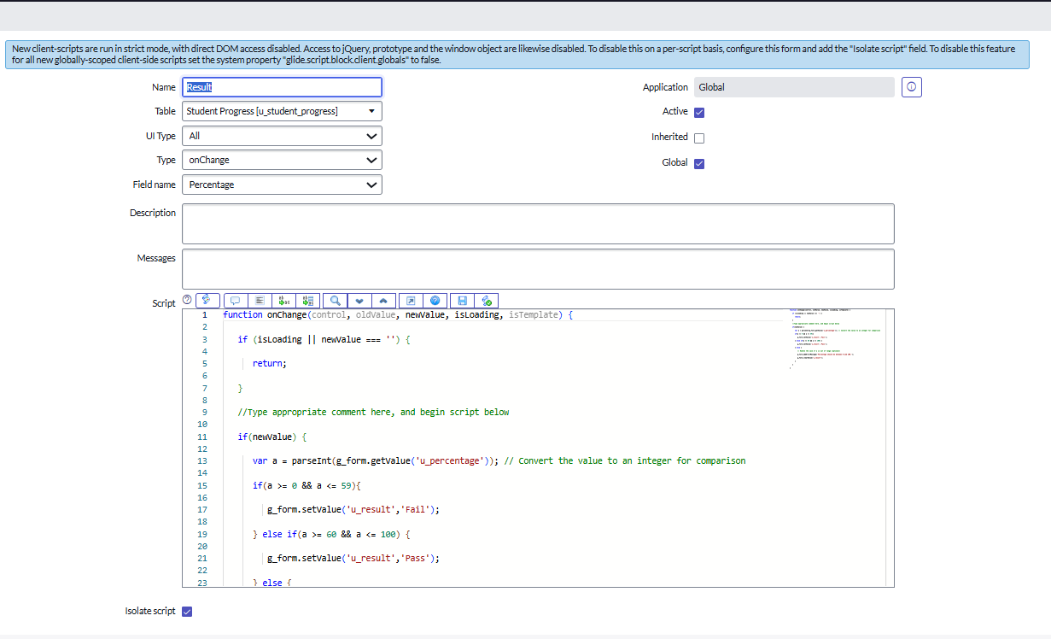

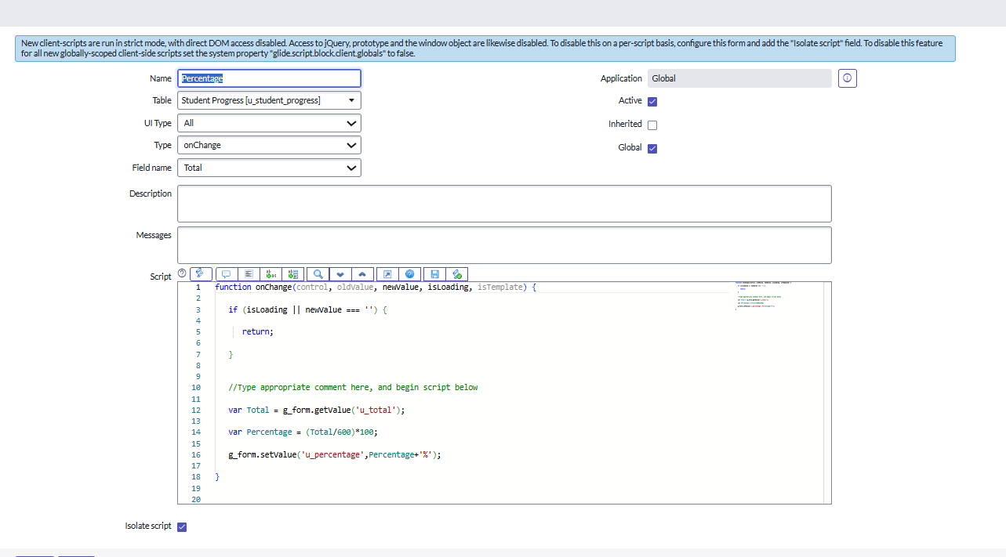

**3. Results and Achievements**

* Successfully created and configured an educational management framework in ServiceNow.
* Automated workflows streamlined admission and academic processes.
* Client scripts enhanced user experience by auto-calculating results, reducing manual errors.
* Form layouts and process flows improved usability for both administrators and faculty.

**4. Challenges Faced**

* Designing client scripts required careful debugging and testing.
* Configuring number maintenance with custom logic for admissions was complex.
* Managing relationships between different tables (Admission–Student Progress–Salesforce) required proper planning.

**5.Conclusion**

This project demonstrated the use of ServiceNow for building an **Educational Organization Management System**. By setting up instances, creating tables, designing forms, implementing number maintenance, process flows, and client scripts, the project achieved automation of key educational processes such as admissions and student performance tracking.